Step 9. Attachment Measure Up
Within this section, you will be measuring up the attachment. It is best practice to setup the attachment between measuring positions 2 and 3. This saves time in the measure up process.
Tools needed:
Plumb bob
Tape Measure
Digital Level
1. Navigate to the Attachments section of the Install Assistant
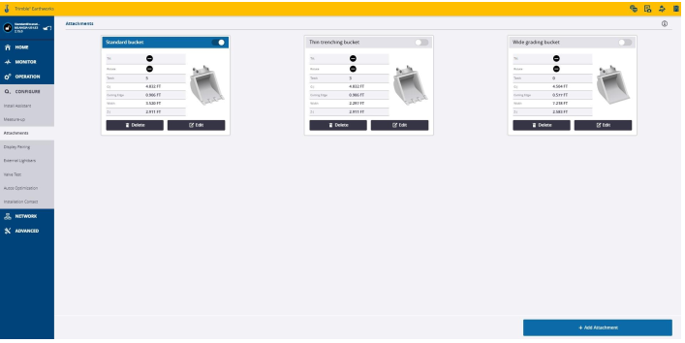
2. Select Add Attachment
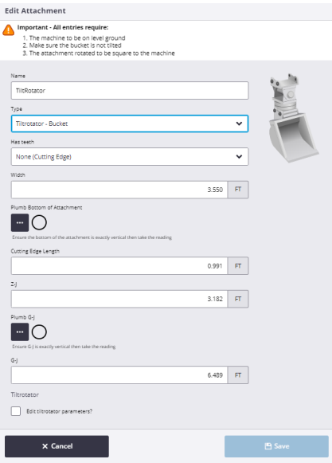
3. Name the attachment, select its type from the drop down, and configure
whether it has teeth and if so, enter the number of teeth.
4. Measure and enter Bucket Width
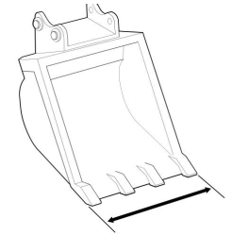
5. Plumb the bottom of the bucket. It is best practice to use a Digital Level for this
portion of the attachment setup.
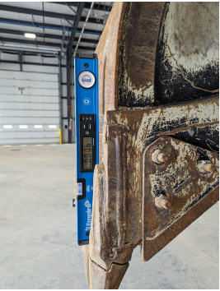
6. Select the 3 Dot button once the bucket is plumbed and allow Earthworks to
take a measurement.
7. Take and enter the cutting edge length, as J-J 1 measurement.
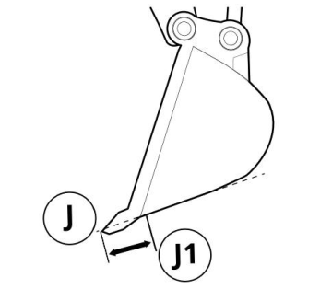
8. Take and enter the Z to J measurement. This measurement is taken between the
bucket tooth and where the bucket floor starts to transition into a curve.
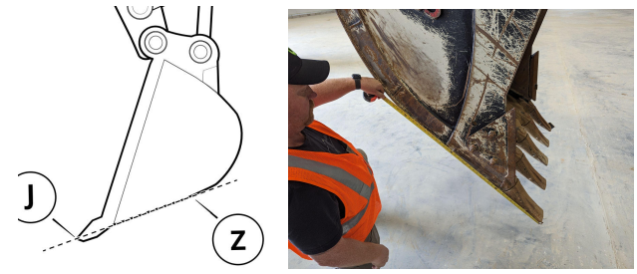
9. Using a plumb bob attached to the G pin centerline, curl the bucket in so that
points G and J are plumbed.
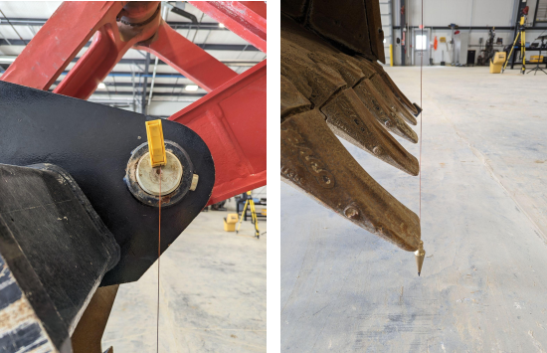
10. Select the 3 Dot button and allow Earthworks to take a measurement.
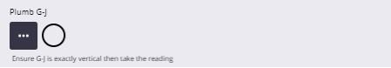
11. Measure the distance between points G and J using a tape measure.
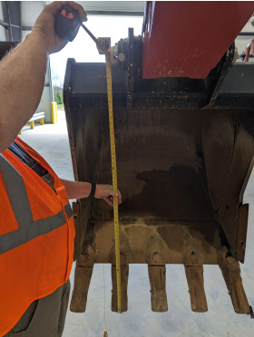
12. Save Attachment settings if type has been set to bucket. Otherwise, continue
with the additional tiltrotator measure up in the next step.

